User Manual [Boxinator]

This document contains a manual for usage of the application called Boxinator.

## Frontpage

A login-page and a register-page is available to a visitor of the website. If the user already has an account, logging in will be the next step. If not, register a new account by navigating to the register-page, filling out the form with the desired credentials. 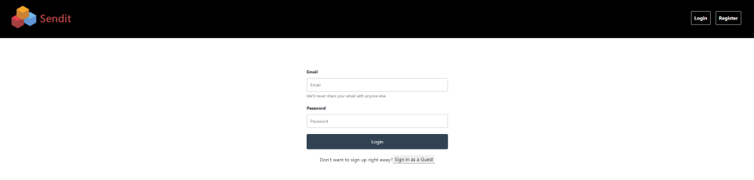

*Figure 1: Login form*

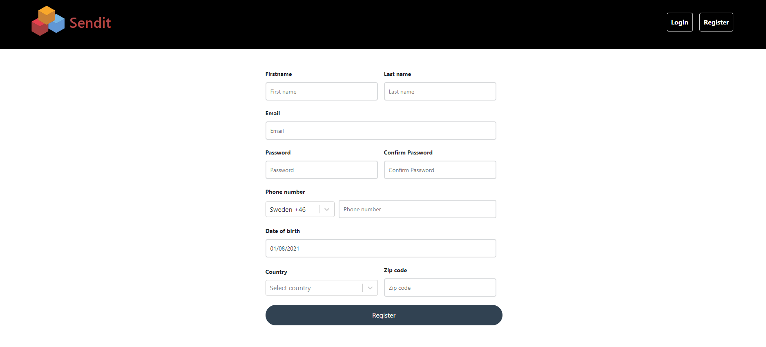

*Figure 2: Register form*

This will send an email asking for verification of the account and then activate multi factor authentication. When trying to login, the user has to verify the login attempt with a code that will be sent to the provided phone number.

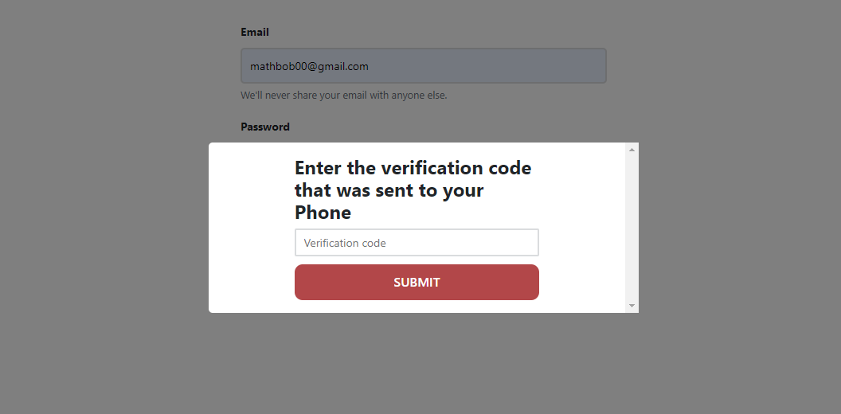

*Figure 3: Verify login attempt*

A user can also choose to not log in and only create a new shipment as a guest. This will require a valid email where a receipt of the shipment will be sent.

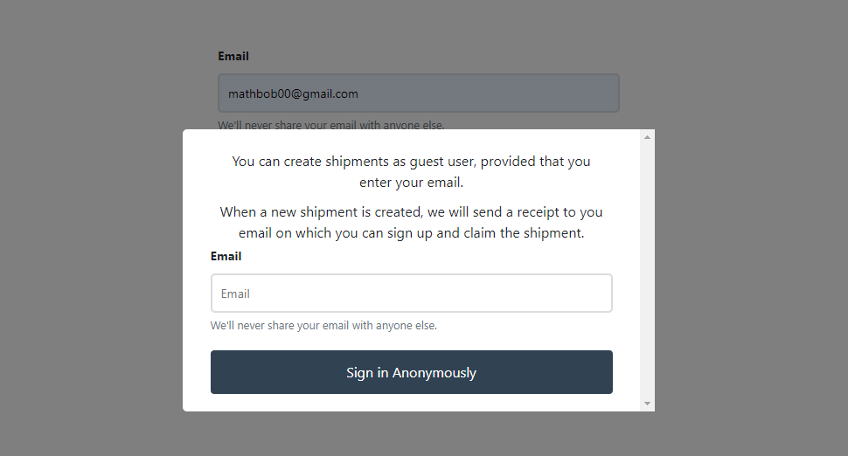

*Figure 4: Sign in as Guest*

The receipt will contain a link where the user can “claim” the shipment. This link will let the guest create an account which in turn will become the “creator” of the shipment.

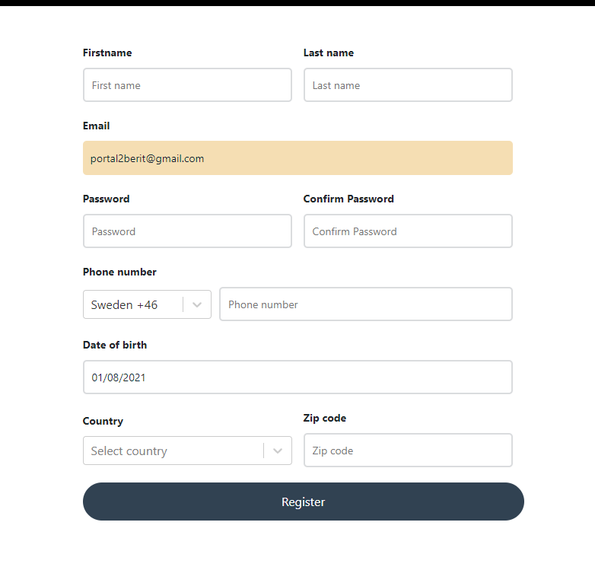

*Figure 5: Register Guest account*

## Logged in as user

When logged in, the user is presented with the “create shipment”-view.

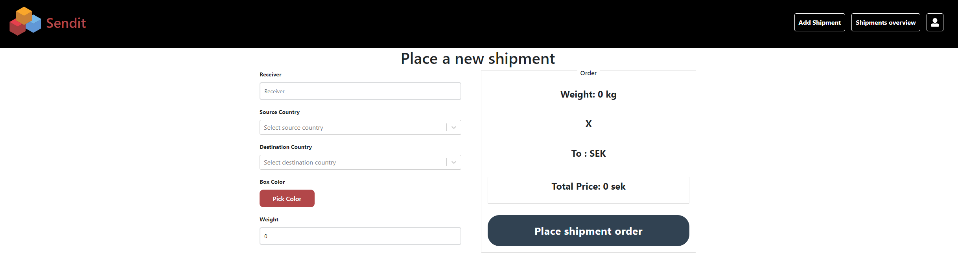

*Figure 6: Create shipment view*

A navbar is present where the user can navigate to a profile page and a page which lists the shipments relevant to the user.

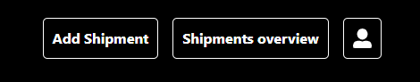

*Figure 7: Navbar for user*

To create a shipment, simply fill out the form and confirm the order inside the modal that pops up.

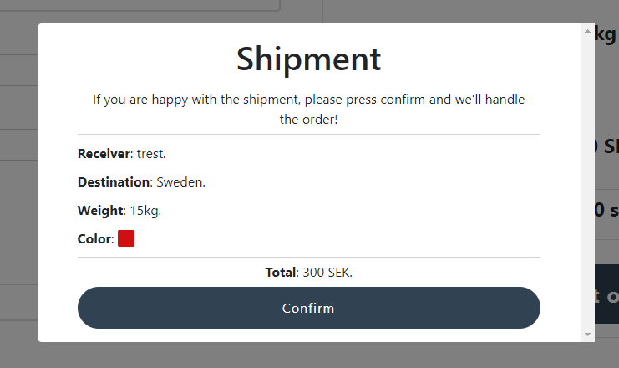

*Figure 8: Confirm shipment popup*

The modal will include all information about the shipment. Once the user has confirmed the shipment, a redirection to the current users shipments will occur. Here the user can see all relevant shipments.

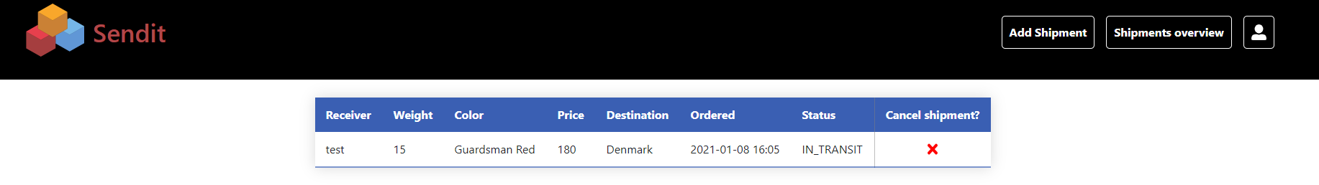

*Figure 9: Shipments view for user*

The user will only have one type of modification to the shipments and that is to cancel a shipment. A user can also navigate to a profile page where information about the account will be shown. The user has the option to edit this information except the ID of the account. This page also has a button where the user can log out.

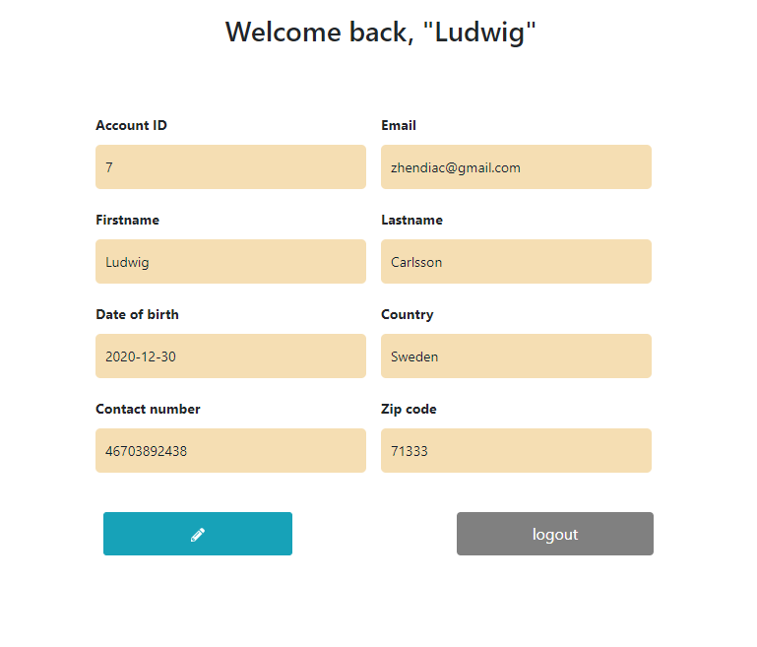

*Figure 10: Profile page*

## Logged in as admin

When logged in, the admin is presented with a menu that contains links to some administrative subpages.

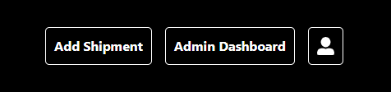

*Figure 11: Admin navbar*

These subpages are lists for all accounts(see figure 12), shipments(see figure 15) and countries(see figure 18). Within these lists, an admin can choose to edit almost all data in all entries(see figure 13, 16 and 19), exceptions being ID’s, price of a shipment and the account that created a shipment. An admin can also choose to remove accounts, shipments or countries but only in extreme cases(see figure 14, 17 and 20).

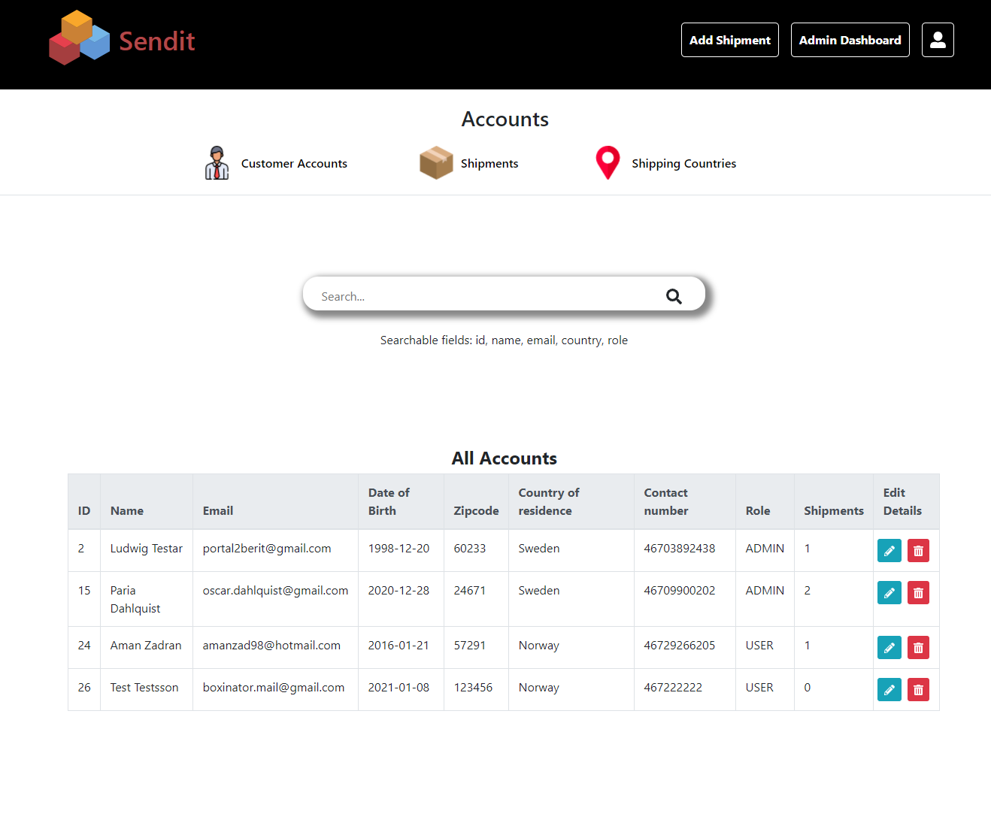

*Figure 12: List of accounts, admin page*

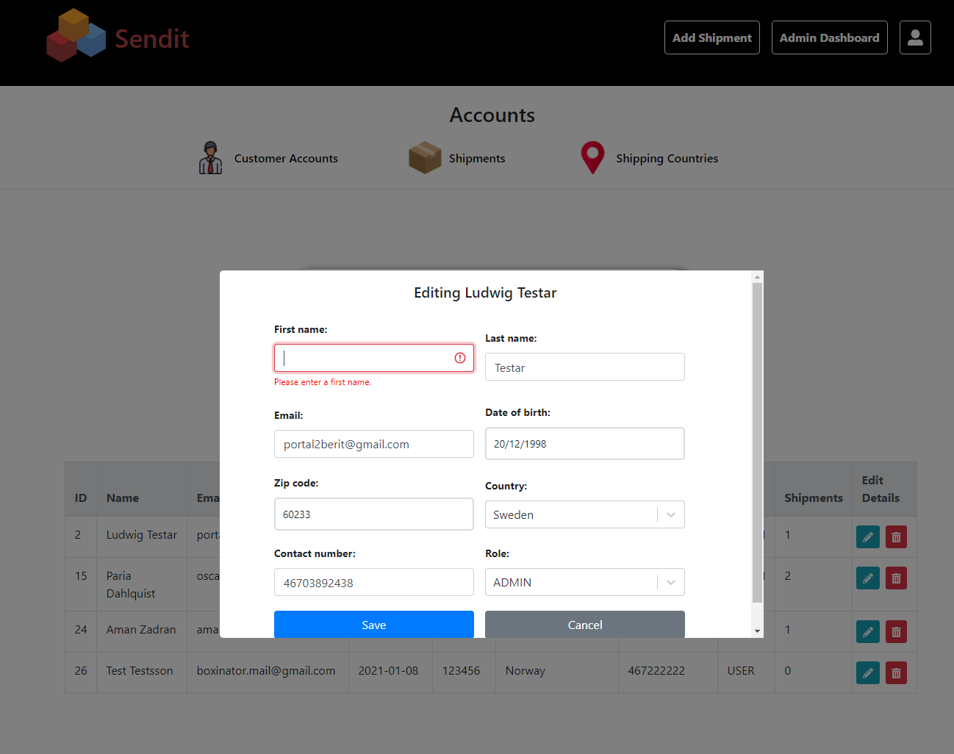

*Figure 13: Editing an account, entering wrong input*

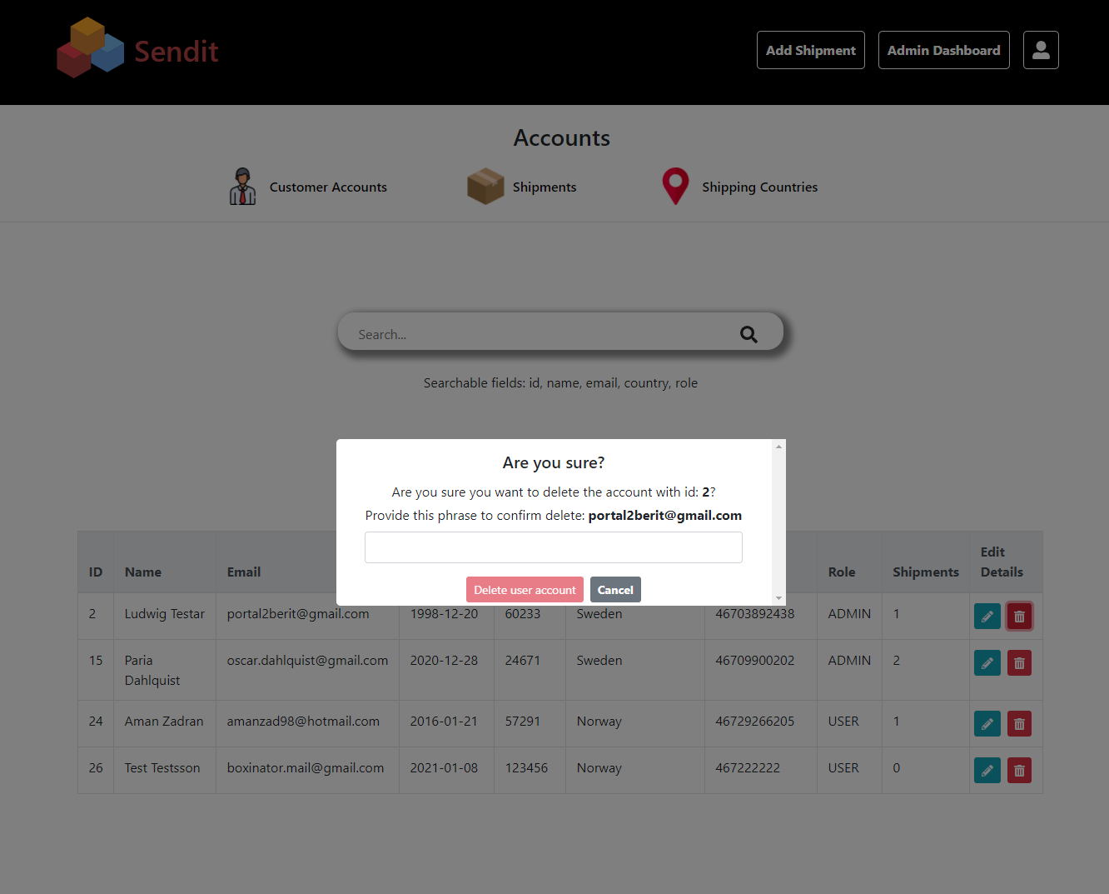

*Figure 14: Deleting an account*

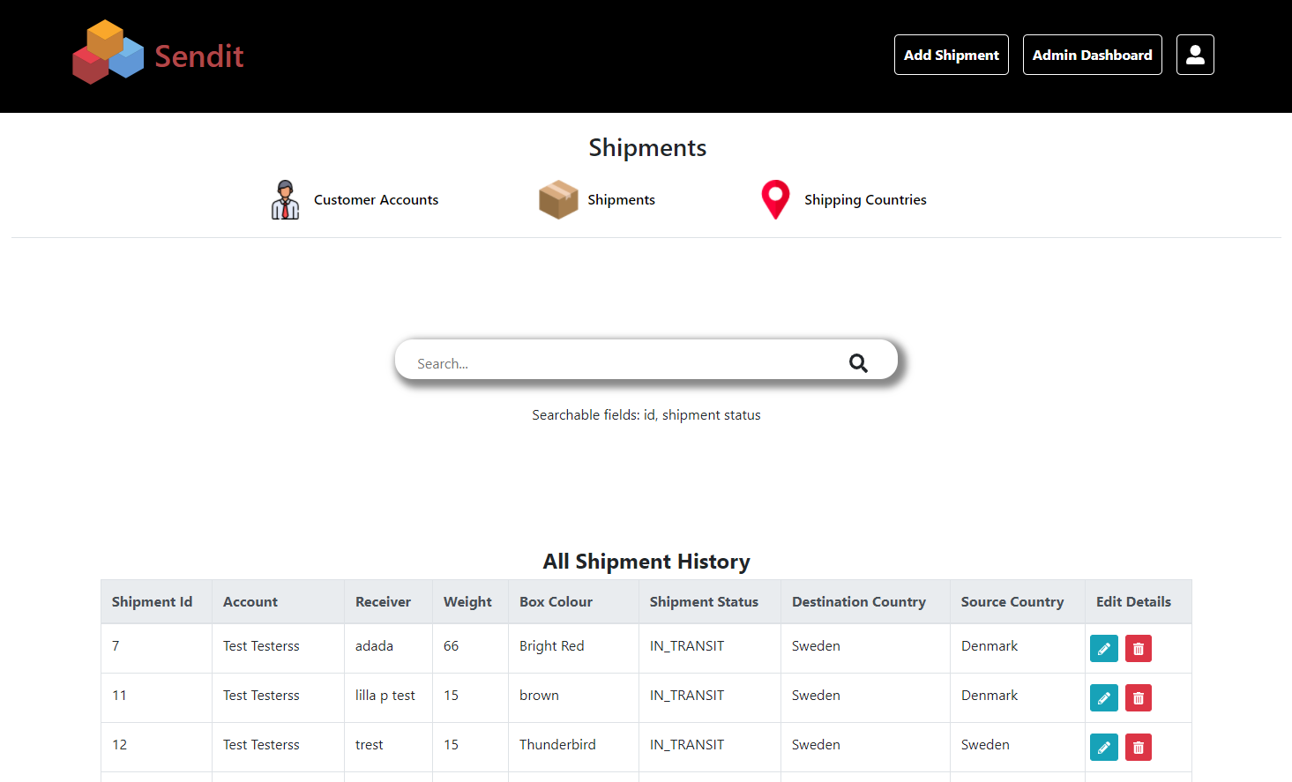

*Figure 15: List of shipments, admin page*

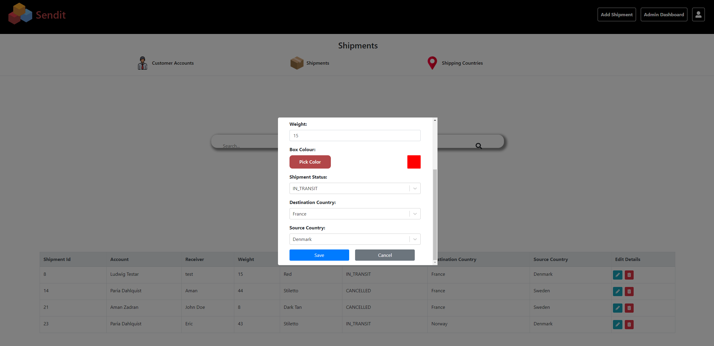

*Figure 16: Editing a shipment*

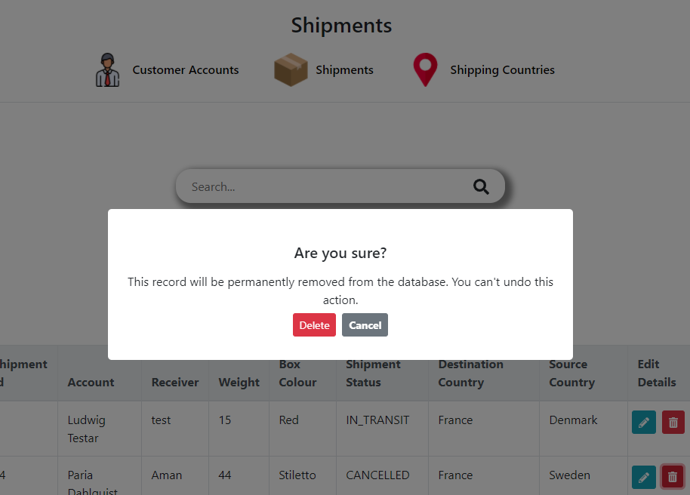

*Figure 17: Deleting a shipment*

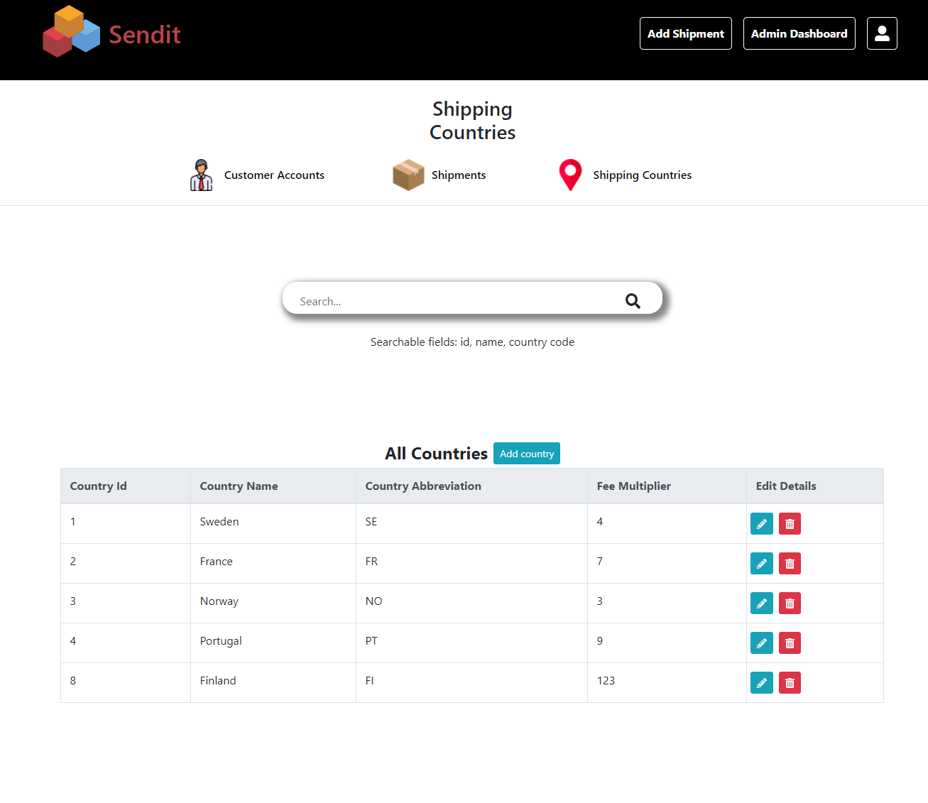

*Figure 18: List of countries, admin page*

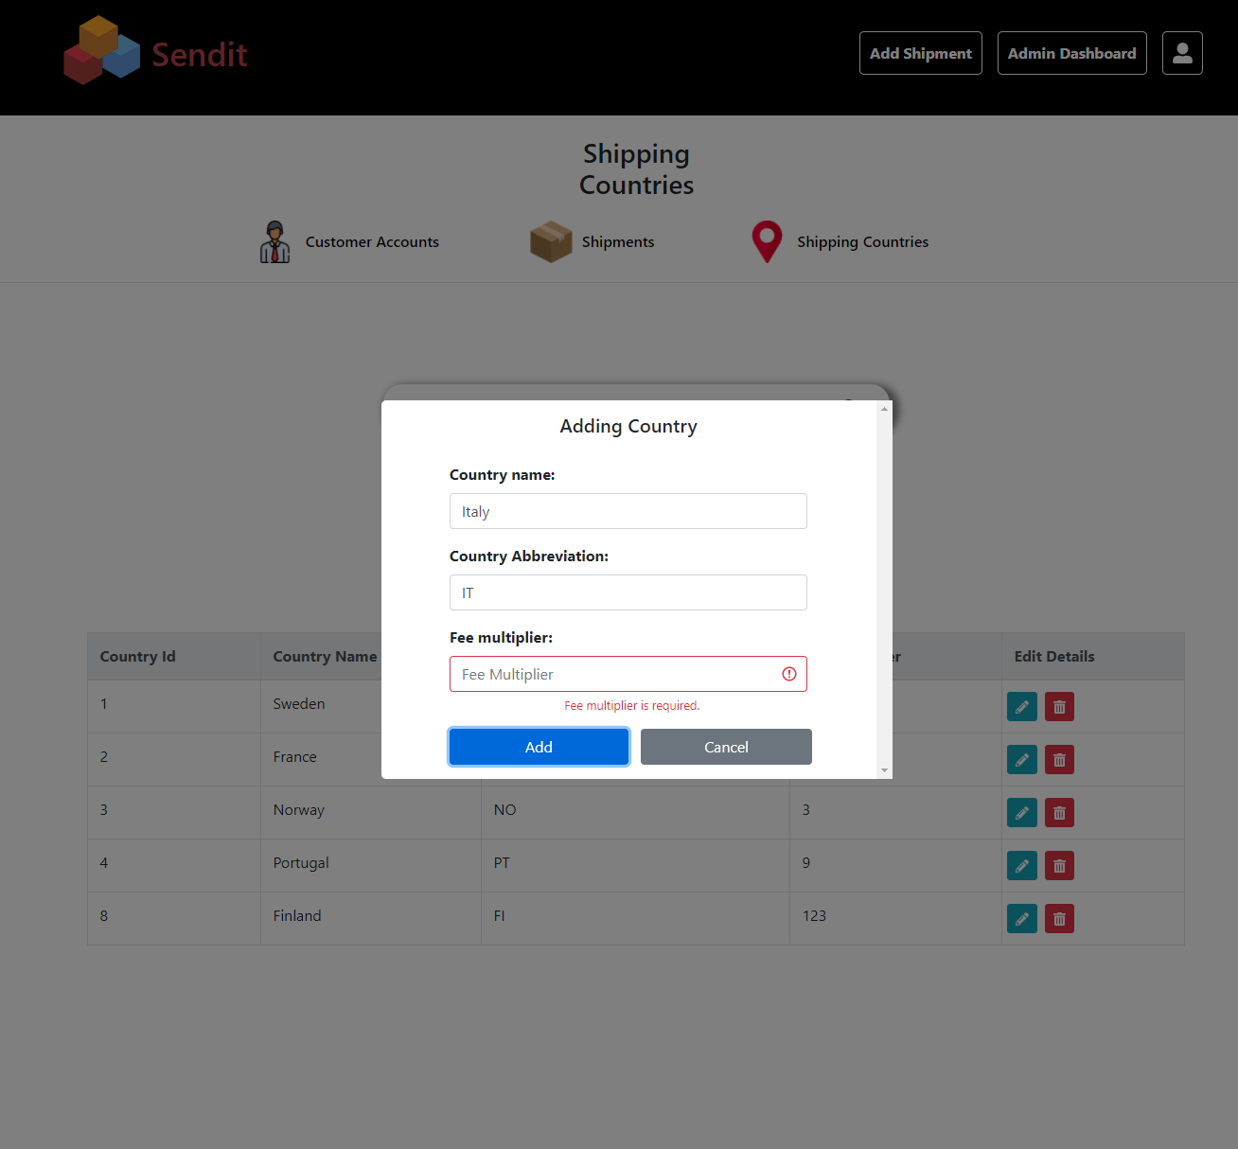

*Figure 19: Editing a country, entering wrong input*

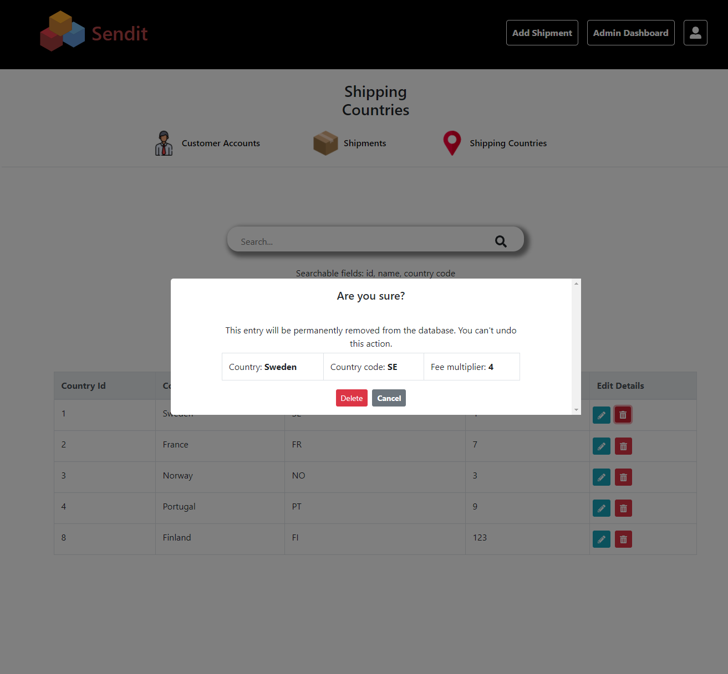

*Figure 20: Deleting a country*